|  |  |  |  |  |  |  |
| --- | --- | --- | --- | --- | --- | --- |
|  | **Project Code:** | | | PRJ-BMW-001 | | |
|  | **Project Name:** | | | BMW Application | | |
|  | **Account:** | | |  | | |
|  | **Vertical:** | | |  | | |
|  | **Location:** | | |  | | |
|  | **Customer Name:** | | |  | | |
|  | **Technical Manager/ Email ID:** | | |  | | |
|  | **Project Manager / Email ID:** | | |  | | |
|  | **Quality Co-ordinator / Email ID:** | | |  | | |
|  | **Customer Contact Information:** | | |  | | |
|  |  | | |
|  |  | | |
|  |  | | |
|  | |  |  | |  |  | |
| **Prepared by/Date** | |  | **Reviewed by/Date** | |  | **Approved by/Date** | |

**Revision History**

|  |  |  |  |  |  |
| --- | --- | --- | --- | --- | --- |
| **Version (x.yy)** | **Date of Revision** | **Description of Change** | **Reason for Change** | **Affected Sections** | **Approved By** |
| PRJ-BMW-001-Version-001 |  | Initial Draft |  |  |  |
|  |  |  |  |  |  |
|  |  |  |  |  |  |
|  |  |  |  |  |  |
|  |  |  |  |  |  |
|  |  |  |  |  |  |
|  |  |  |  |  |  |
|  |  |  |  |  |  |

**Affected Groups**

|  |
| --- |
| Testing Team |
| Development Team |
| Client |
|  |

**List of Reference Documents**

|  |  |
| --- | --- |
| **Name** | **Version No.** |
| 1. | Use case doc |
| 2. |  |
| 3. |  |
| 4. |  |

**Introduction:**

## Here is the BMW application where the user can extract information about BMW models, BMW dealers, BMW services etc. based on the provided criteria. The user can also shop for BMW accessories; search or sell used BMW cars and also take loans and leases. The modules under this application include Models, Services, Finance, BMW World, Dealer Location, Test Drive, etc.

**Operational Concepts and Scenarios**

**Module 0:** BMW-Generic

**REQ-00**: The user should be able to invoke the BMW application in Chrome/Firefox Browser using the URLhttps://www.bmw.in/

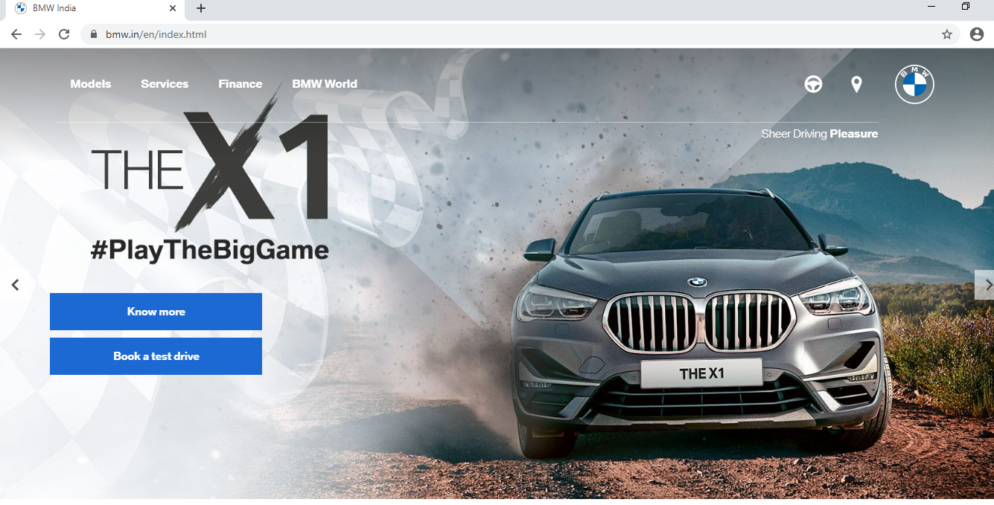

**Module 1**: BMW - Models

**REQ- M1 – 001**: The user should be able to search for required models by entering proper information through Discover all models -> Find Your BMW

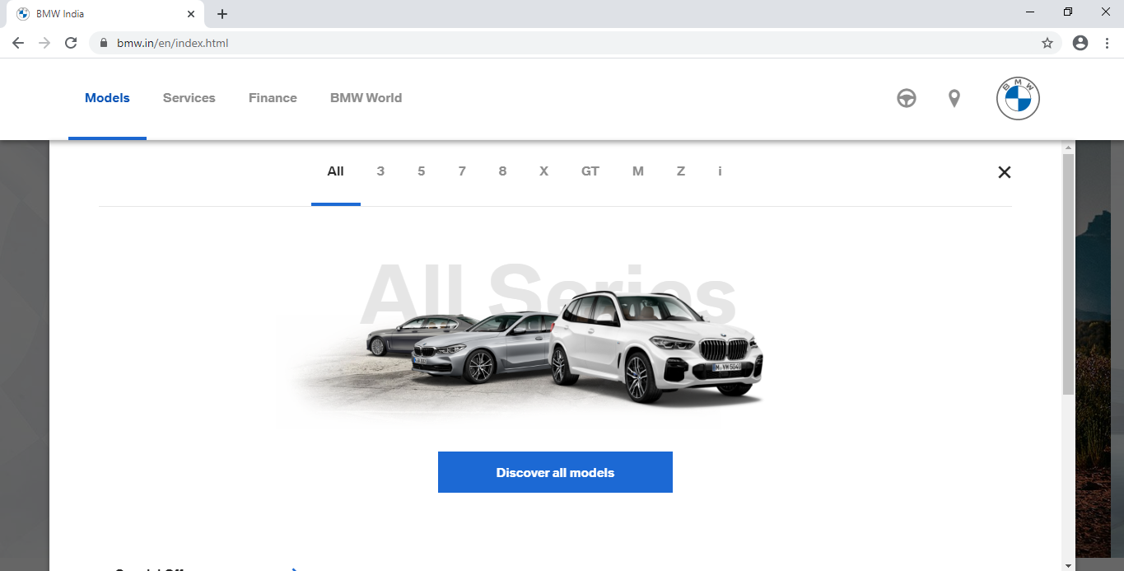

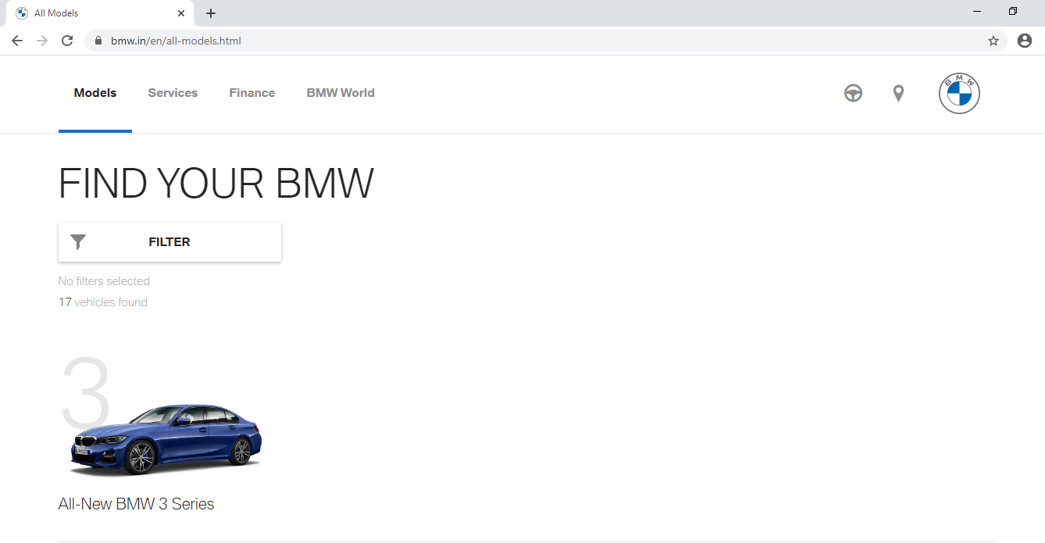

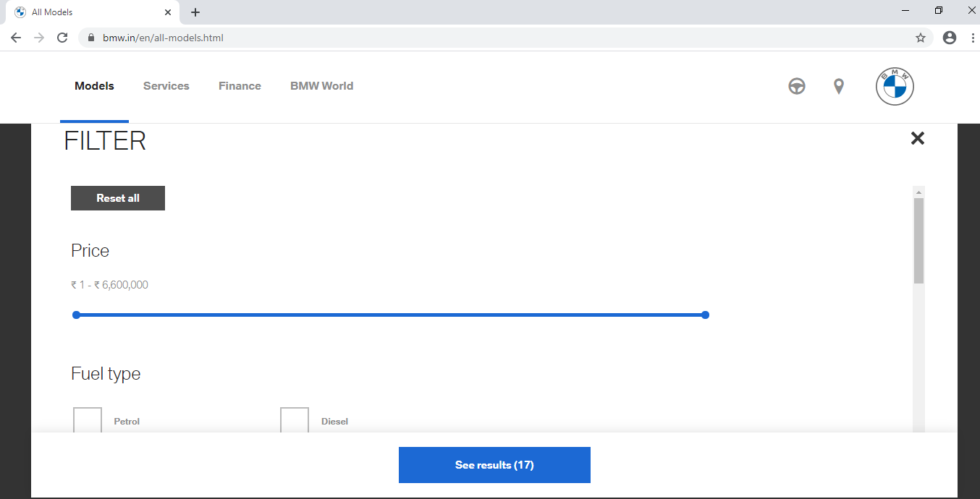

REQ-M1-002: To search for BMW Pre-owned Cars in used cars models based on the requirements and checking weather proper results are viewed according to the filters

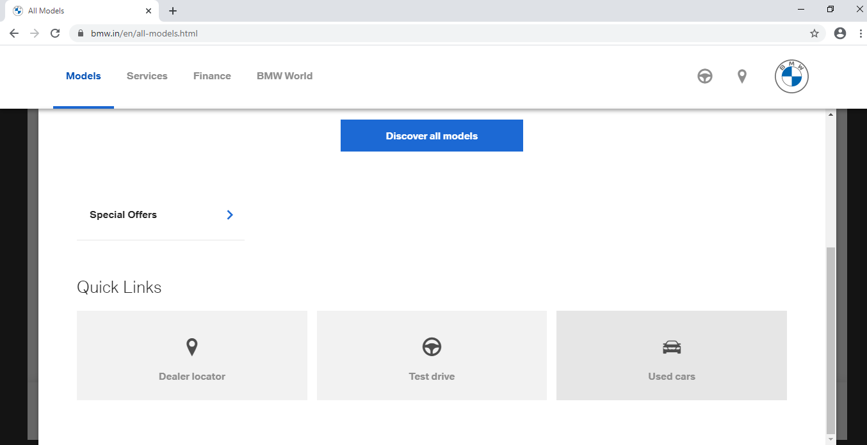

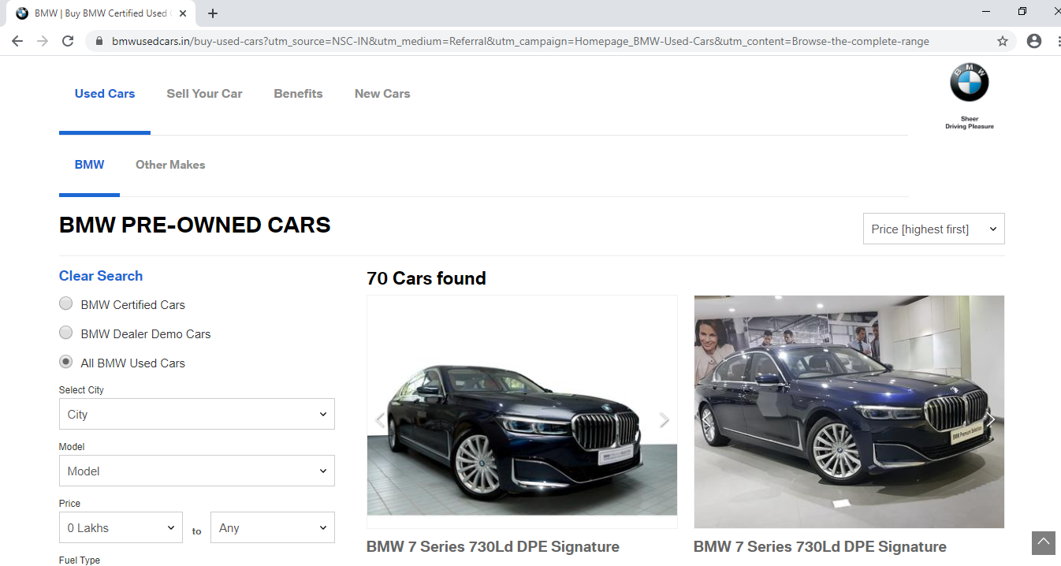

REQ-M1-003: To check if the user is able to search options for selling used cars models by providing all the details.

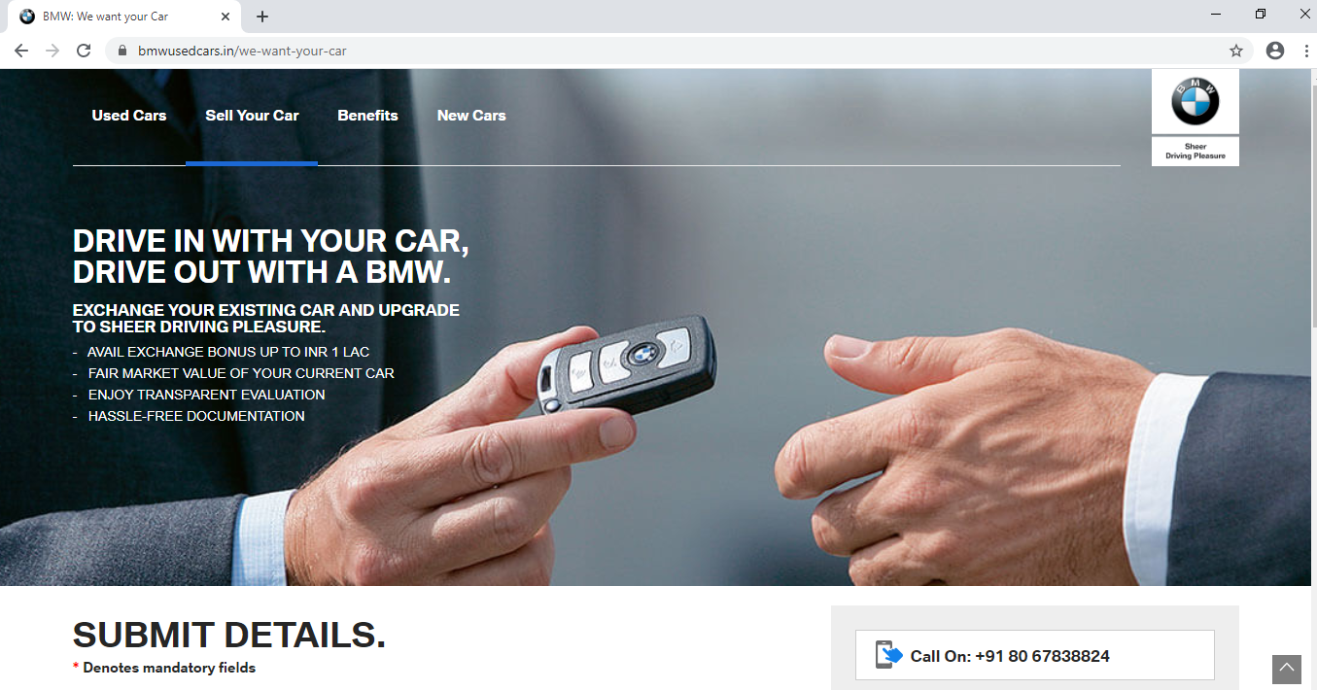

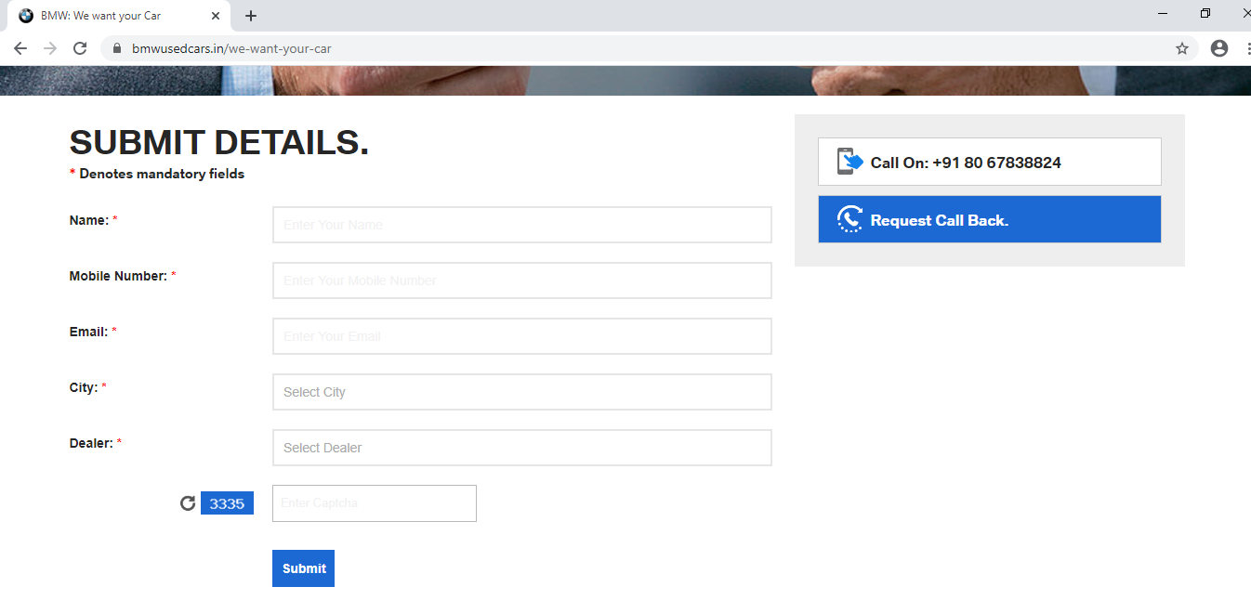

REQ – M1-004: Extract Technical Data of Engine, Performance & Fuel consumption for BMW 7 Series Sedan from Model.

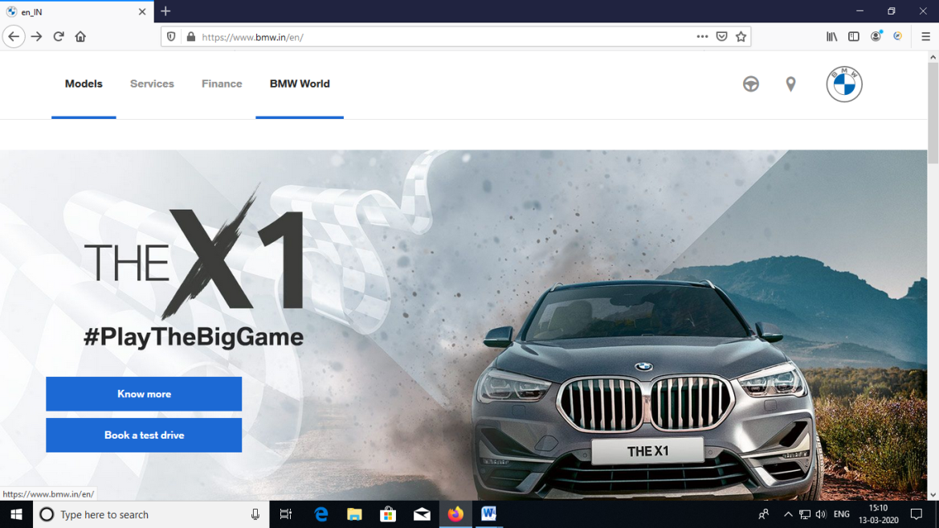

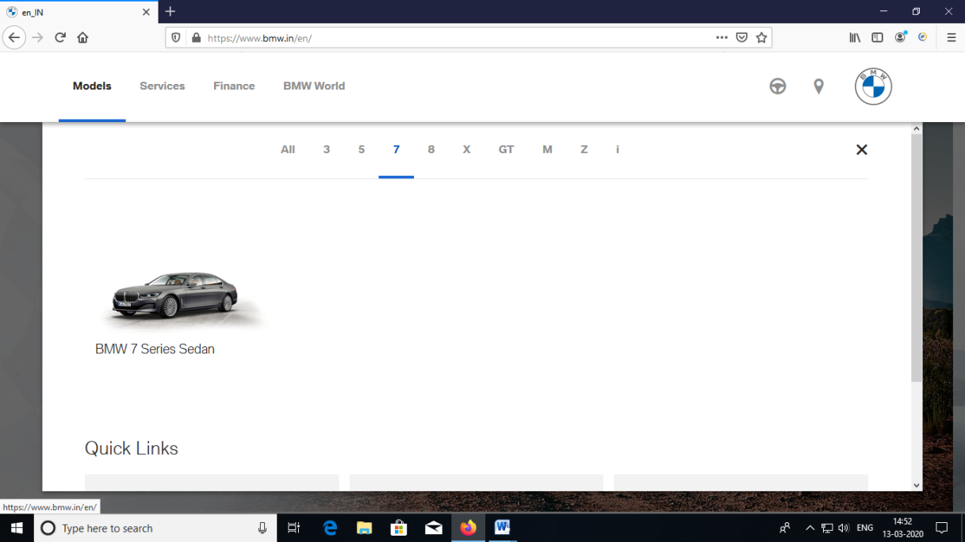

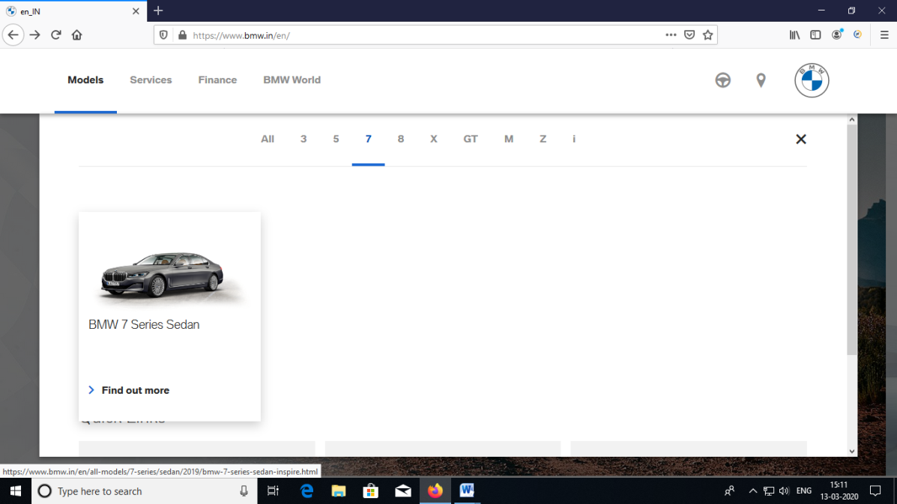

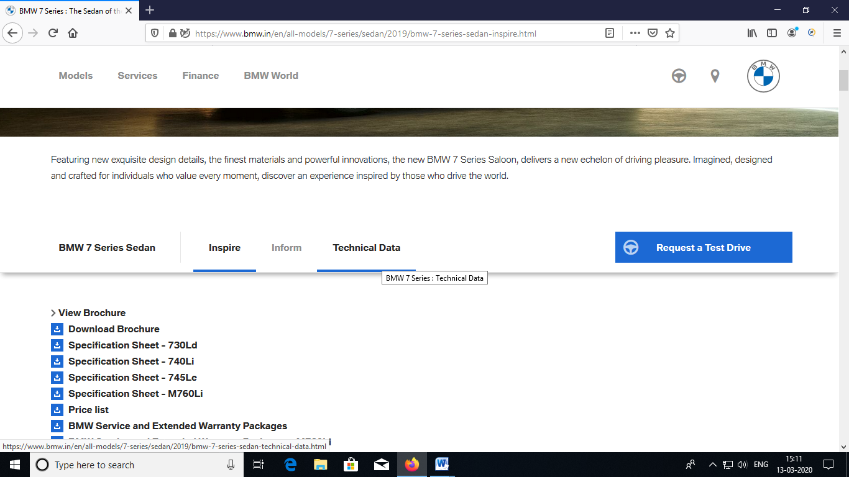

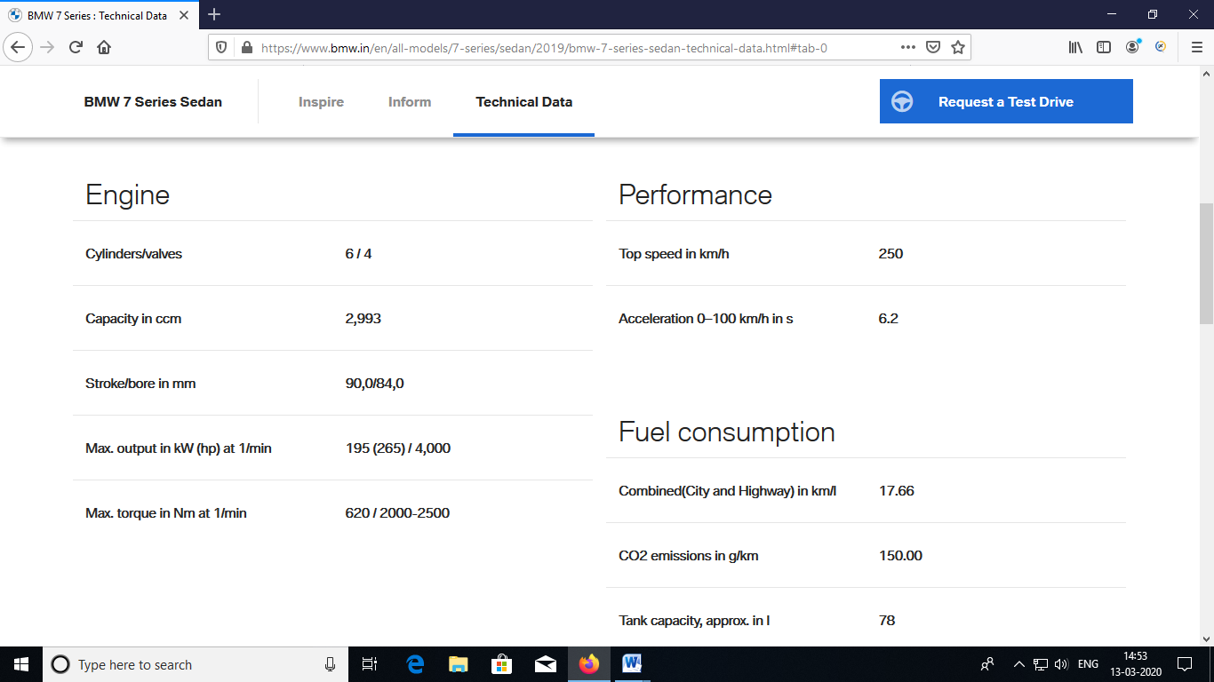

Module-2:BMW_Services

REQ-M2-001: The user can be able to register for joy rewards.

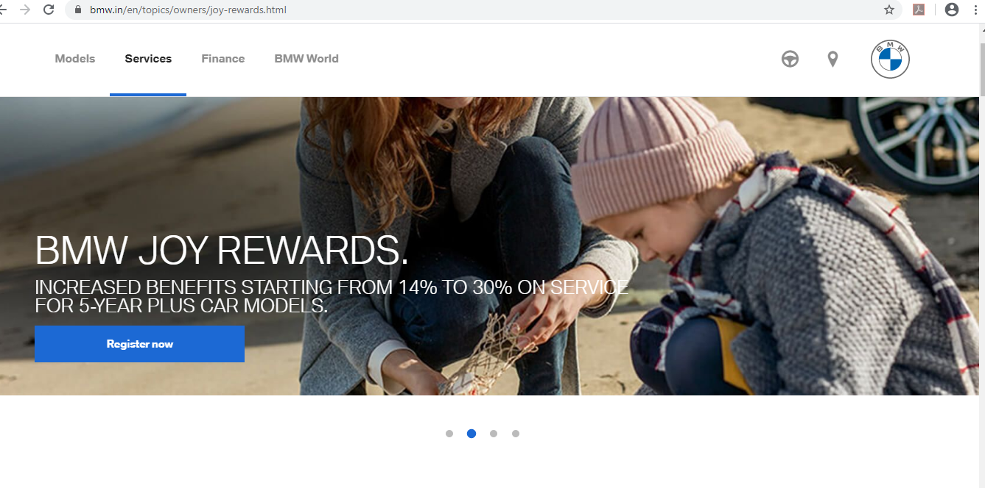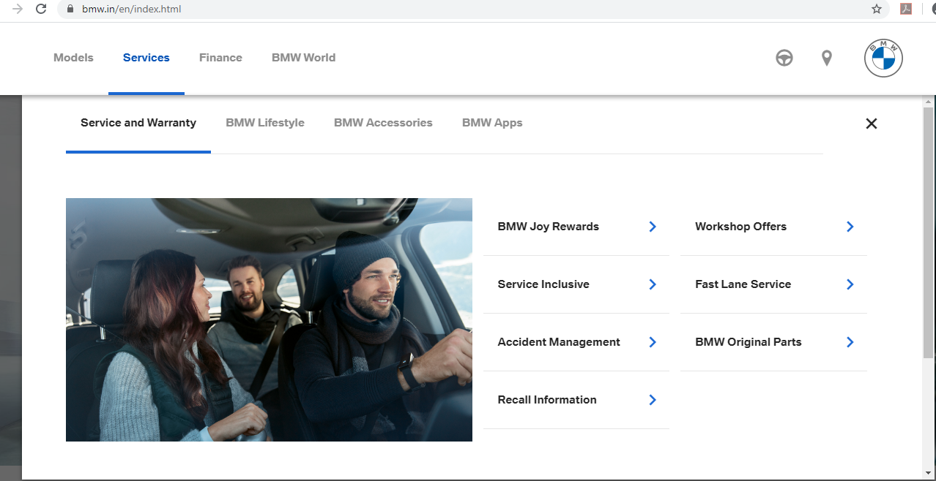

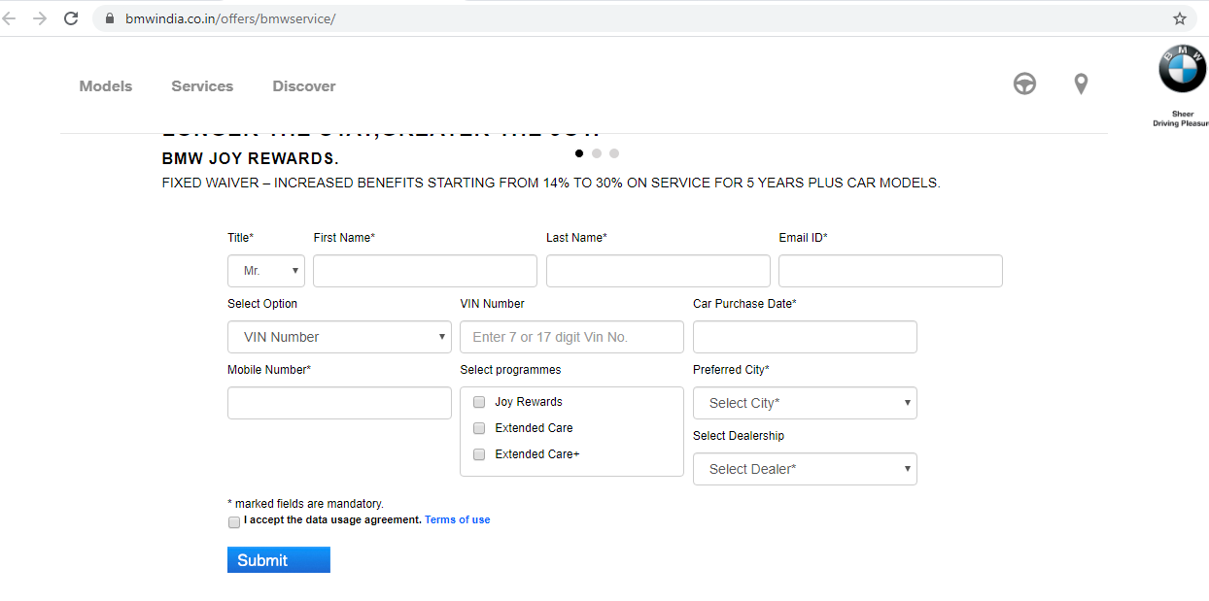

REQ-M2-002: The user can able to check the car care products from BMW Accessories

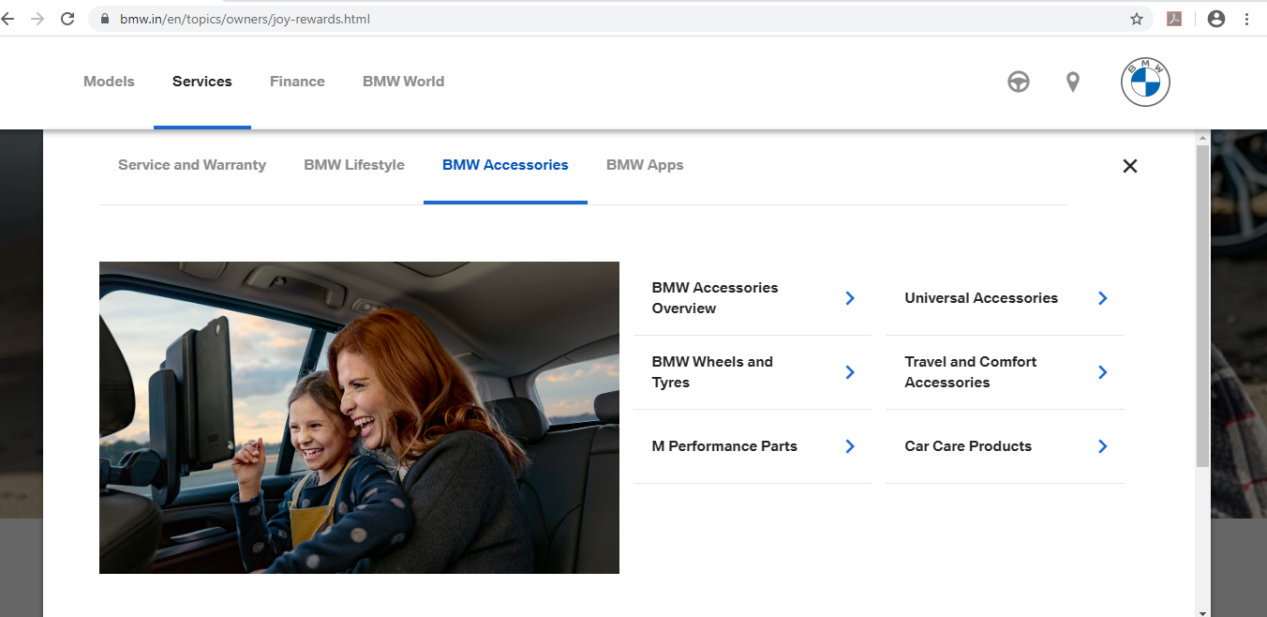

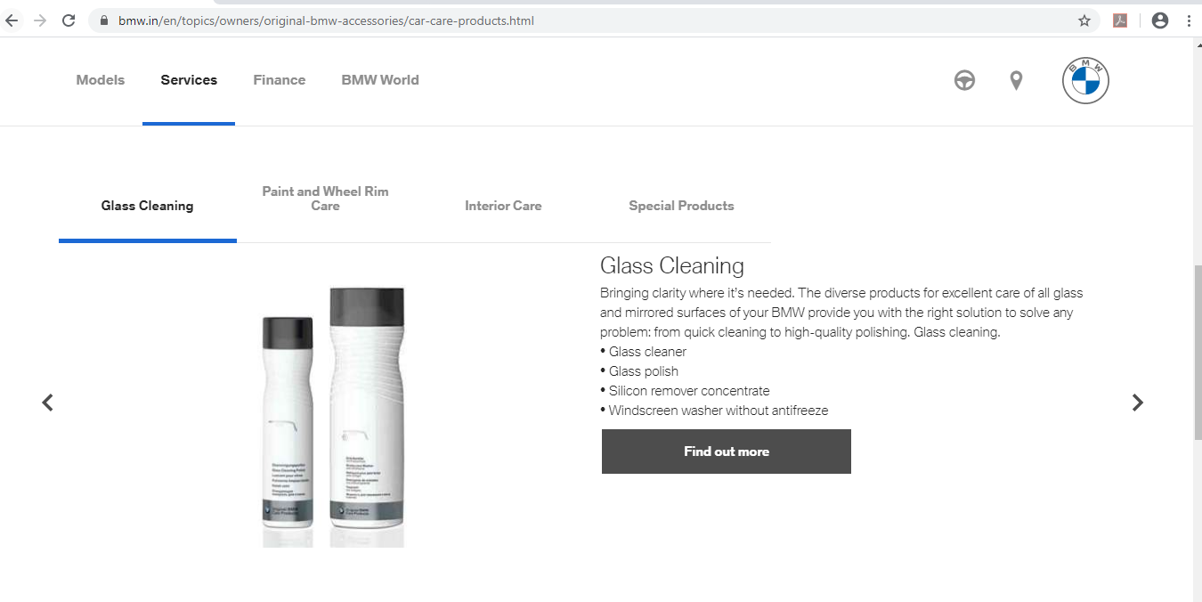

REQ-M2-003: The user can be able to download the BMW application through BMW apps->Overview.

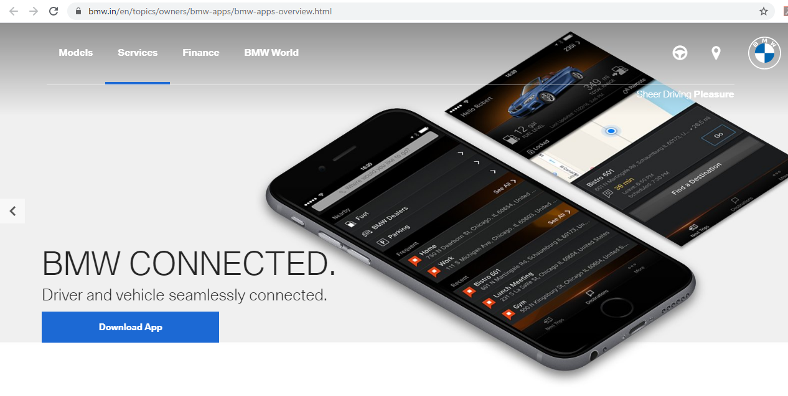

REQ-M2-004: To check the user can be able to navigate to Google play by clicking on watch faces through Lifestyle and gadgets.

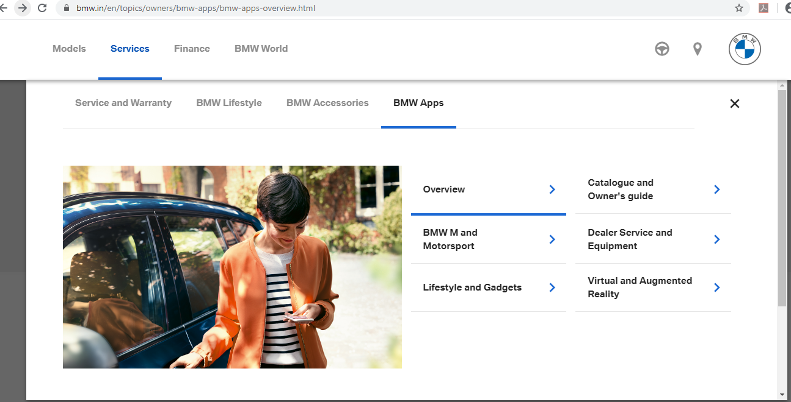

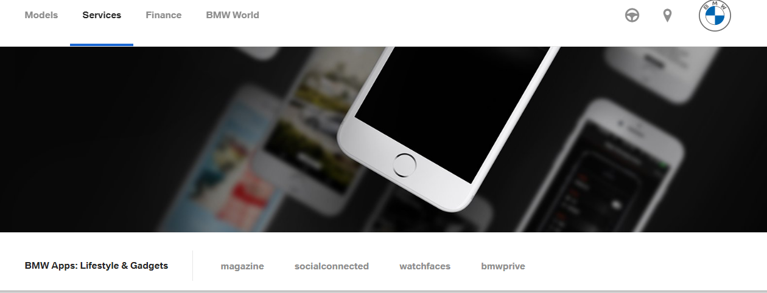

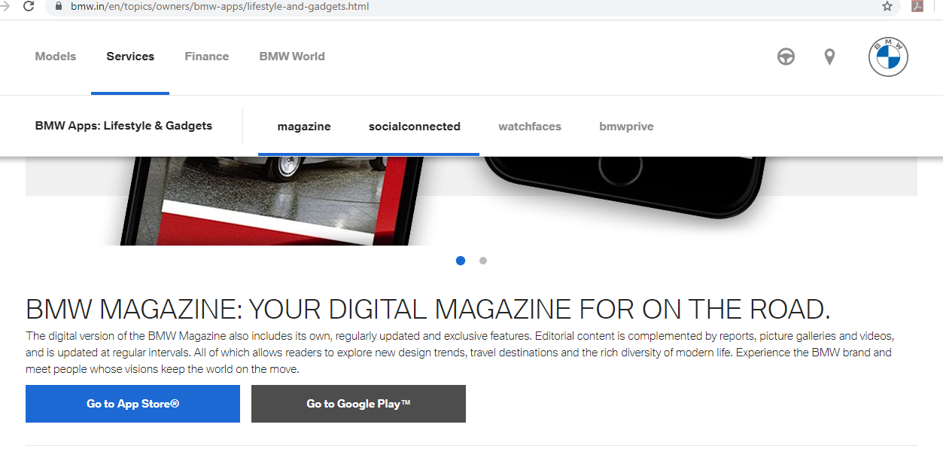

Module 3 : BMW-Finance

REQ-M3-001: The user can able to extract “The BMW Balloon Plan” text.

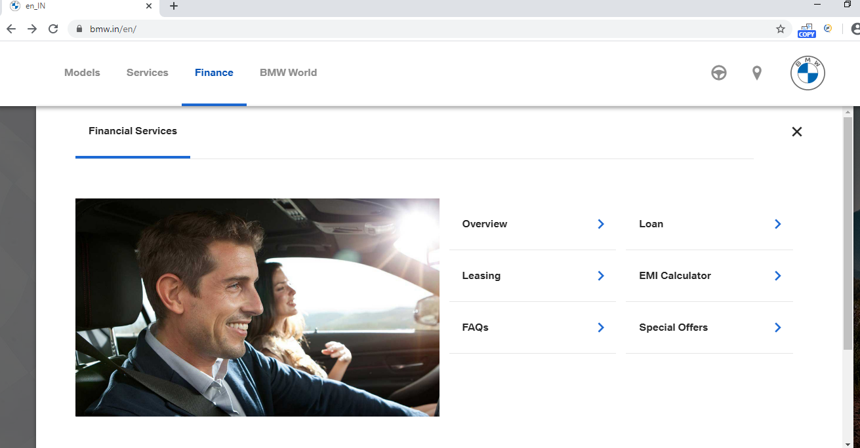

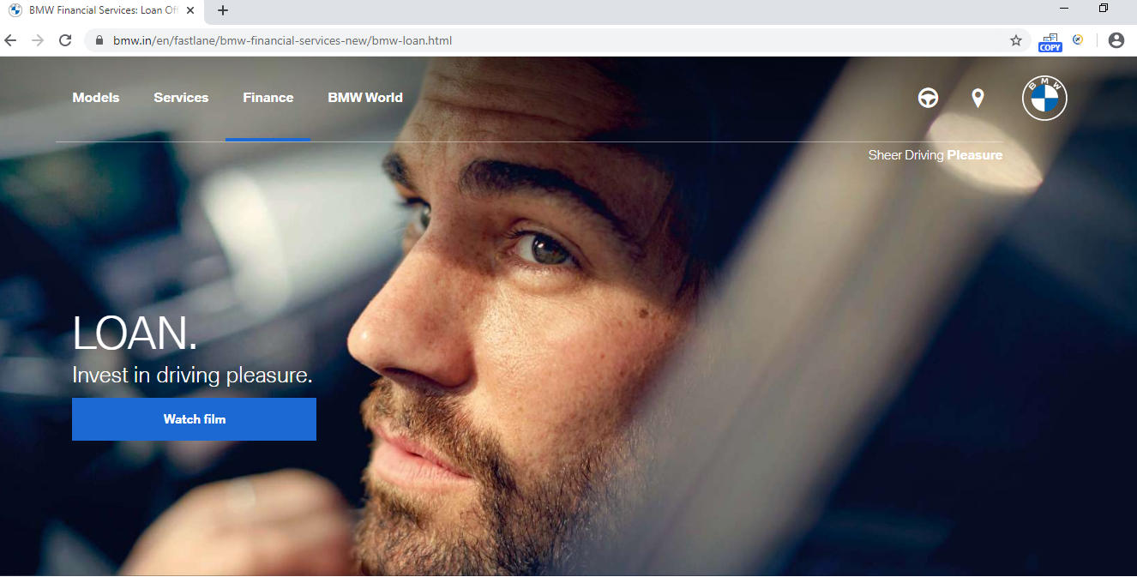

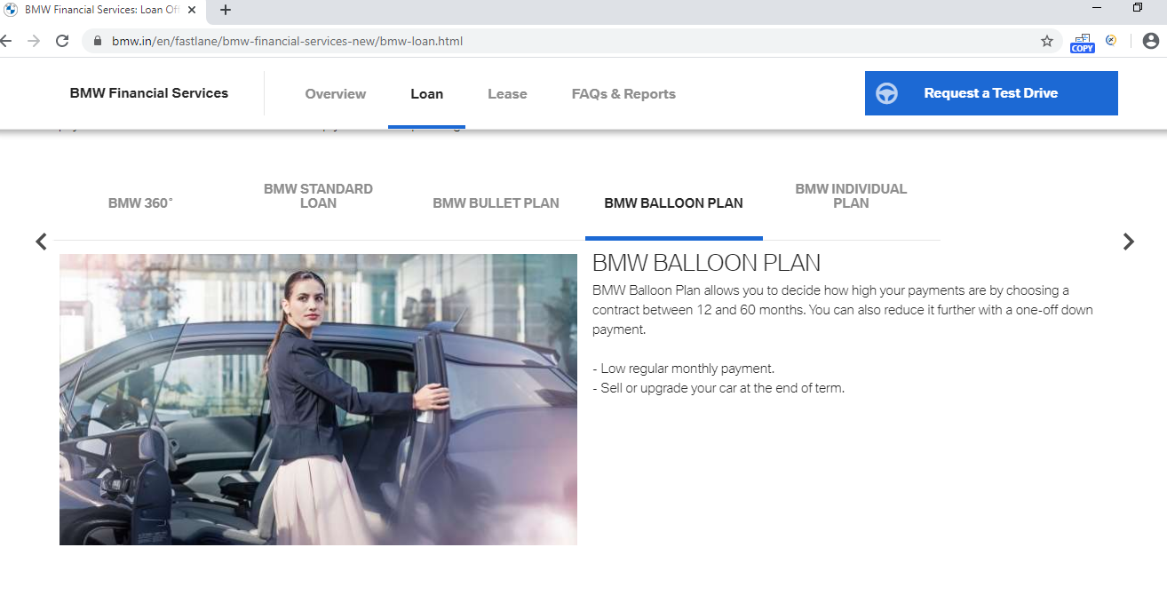

REQ-M3-002: The user can able to calculate the Balloon amount through EMI Calculator and extract it.

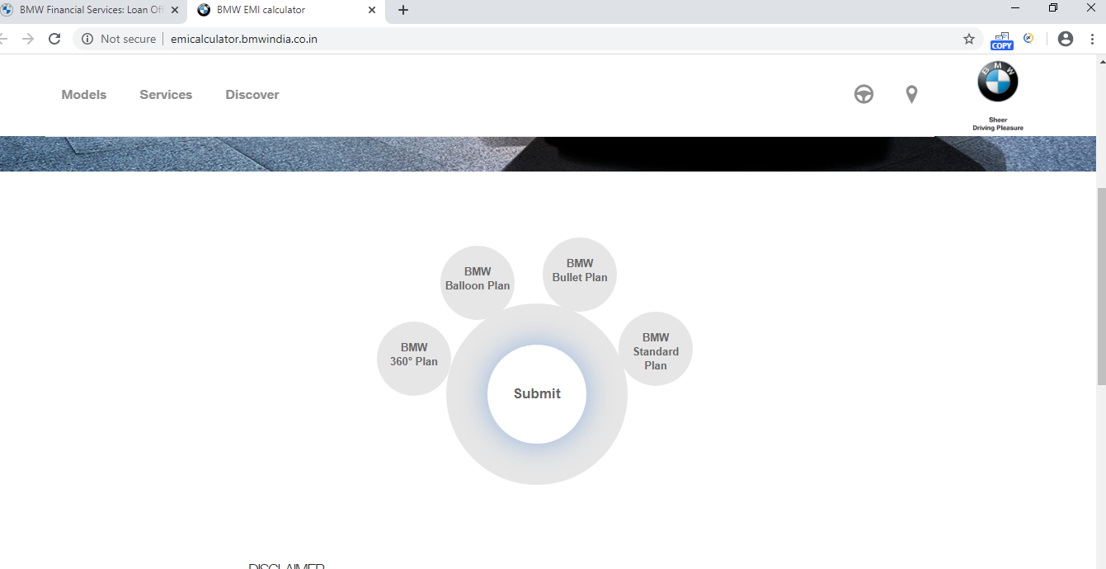

REQ-M3-003: The user can able to click on “More Information” and get the information about THE ALL-NEW BMW 3 SERIES.

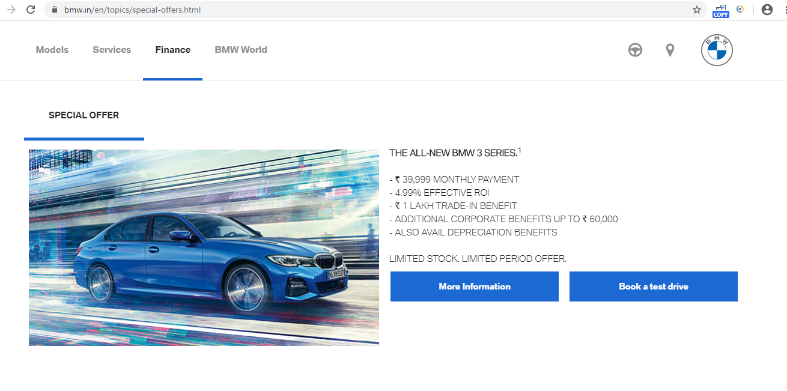

Module-4: BMW World

REQ-M4-001: The user can able to extract the “Project I Vision Dynamics “from BMW World

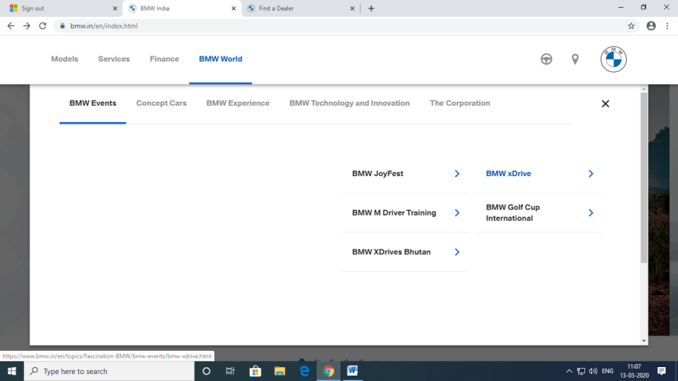

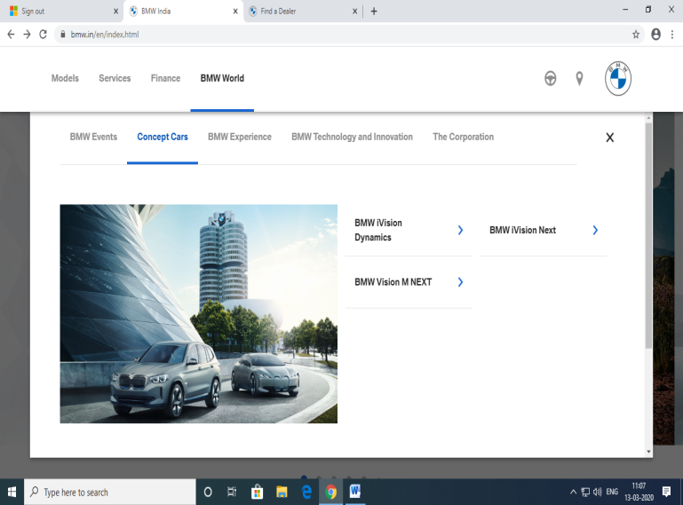

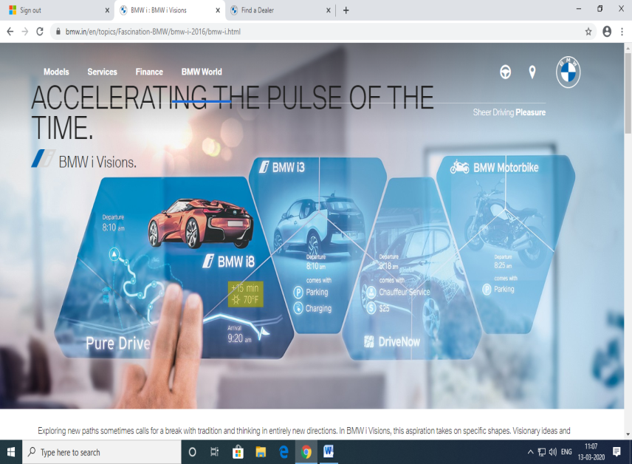

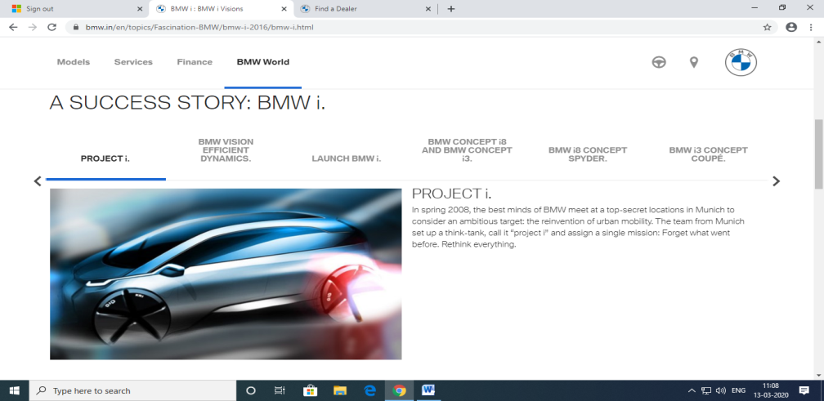

Module – 5: Dealer Locater :

REQ-M5-001:

The user can able to access the Module Dealer Locater by clicking on Dealer Locater.

